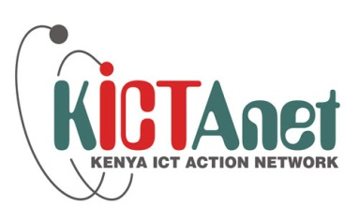
Time | Agenda | Speaker
7:30 -7:45 | Emcee  Introductions/Opening Remarks  Welcoming Remarks  Opening Remarks | Grace Mutungu-KICTANet  Grace Githaiga – Co convenor, KICTANet  Dr. Joseph Nasongo – Commissioner NCIC  Commissioner Irene Njeri-Wanyoike  NCIC  Vice Chair
7:45 – 8:00 | Presentation of online debate | Mercy Mutemi–KICTANet debate moderator/Advocate
8:00 – 8:30 | NCIC response to questions raised during the online discussions | Moderator: Dr. Matunda Nyanchama– Agano Consulting  NCIC team
8:30 – 9:10 | Panel Discussions, Q&A | Moderator:Dr. Matunda Nyanchama– Agano Consulting  NCIC Team  James Wamathai – Bloggers Association of Kenya
9:10 – 9:30 | Vote of thanks and way forward | Olive C Metet, MPRSK NCIC-  Grace Githaiga KICTANet

