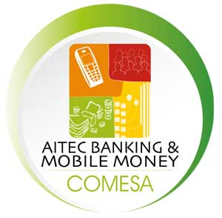
Panafric Hotel, Nairobi
30-31 August 2016

50% VIP PARTNER DISCOUNT ON DELEGATE FEES FOR
AITEC PARTNERS
- $295 PER DELEGATE (inc VAT)

Details of contact person co-ordinating your delegation’s participation:
Company name:
Name of person in charge of booking delegation:
Job title:
Email:
Mobile: Landline:
Postal address:

Delegate booking form: Details of nominated delegates
Name | Job Title | Email address | Mobile Number

REGISTRATION
Please return the form to sheilaa@aitecafrica.com
We will issue an invoice for payment of the delegate fees.
For more information please phone: +254 (0)731942614
AITEC Conferences Kenya Ltd
AITEC House, Cosmos Estate, 1st Ave Parklands
PO Box 63799, Nairobi 00619, Kenya
Tel: +254 723764 118, +254 0738 767 150
www.aitecafrica.com

