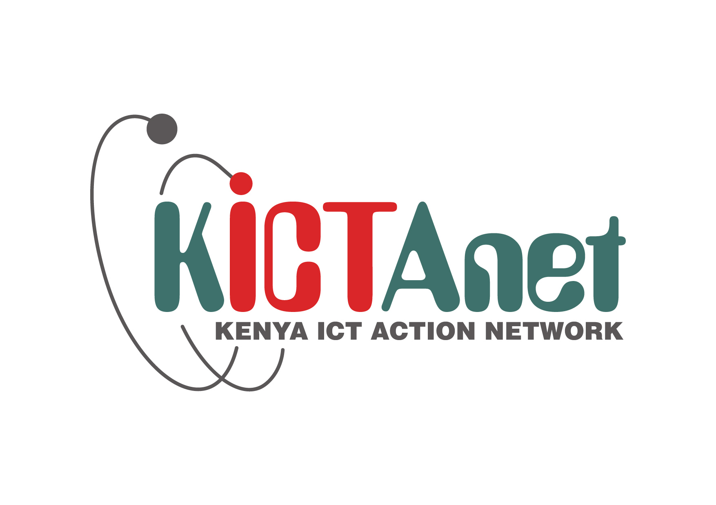
#FIRST100Days
www.kictanet.or.ke
Presented to the new ICT Cabinet Secretary and the two Ps (ICT and Innovation, and Broadcasting and Telecommunications)
January 22, 2016 at the Nairobi Serena Hotel.
ICT WISH LIST
- Policy and legal issues
- Regulatory issues
- Human Capital/Workforce Issues
- ICT Infrastructure Issues
- ICT Information Infrastructure Issues

In the wish list

Policy& Legal issues

#To be Reviewed in the First100Days:
1. Universal Service Fund: Operationalize it & open it up for public participation in as far as policy development, concepts, & selection of projects is concerned (x2)
2. Revise policies to have more women, youth, PWD and marginalised persons perspectives as well as have their input during implementation (x2)
3. Provide Policy for promoting and integrating ICTs in Counties (x2)
4. Ensure Inclusivity in policy development/implementation by enhancing the multi-stakeholder model to include civil society, academia, media, tech community, etc.(also officiate in some of their functions).(x2)
5. Provide Policy Guidelines on Re-Use of Public Sector Information by interested parties (content providers), including value addition and commercialization.
6. Develop a (policy) framework where Govt builds ducts country-wide (not fiber) and develops a business model where private sector leases the ducts to light their own fiber
7. Give Policy/Regulatory direction on Net Neutrality issue
8. Provide regular ‘project status’ for ICT projects/initiatives in order to enhance clarity in the way ICT projects in Government are progressing/being managed.
9. Improve the relationship between the Government and the media fraternity.
10. We had some great announcements on Taxes for ICT equipment in the recent Trade Talks; please elaborate on what will be implemented, and when it will be implemented
11. Have policy on ICT procurement and centralize ICT project mngment in Government
12. Advise/Elaborate more on the intra Africa e-commerce agreement led by Ghana and Kenya.
13. Reconfigure the BPO policy to focus on getting high-skill jobs beyond than the entry-level voice /data transcription services.
14. A consultative meeting with the industry & community on key pending ICT legislation/regulatory/policy issues: East African Electronic Transactions Act; CA Regulations; Data Protection Bill.

#To be Reviewed in the Next 100Days
1. Ensure Access to Information Bill is passed into law (x2)
2. Enact the Data Protection Bill with stakeholder input (x2)
3. Enact Cyber Security laws
4. Restructure Telkom Kenya and drive towards rebuilding the services and the brand
5. Establish the Office of the Government CIO
6. Restructure ICTA to be the Office of the Government PMO - IT
7. Empower the ecommerce sector through tax incentives
8. Provider legislation similar to the US, Health Insurance Portability and Protection Act (HIPPA). – enabling provisioning of e-Health Records.

Regulatory Issues

#To be Reviewed in the First100Days:

1. Bring down the cost of Internet Access/Service – make it affordable (x2)
2. Increase Household Internet Penetration within Counties (drill down internet statistics to County rather than just National level) .
3. Incentivize Operators to extend networks beyond urban areas (using Universal Service Fund?) (x2)
4. Ensure persons with disabilities (PWD) are catered for within the ICT ecosystem (e.g Govt & Public Websites/e-Services, TV broadcasts, etc)
5. Respond to qtn: Why should internet bundles expire, is it legal?
6. Resolve the contentious Safaricom 'Dominance' issue. Perhaps through the anti-dominance legislation/regulation?
7. A revitalised engagement by the CS and PSs directly with the Kenya ICT Community, through KICTANET, the KE-IGF, roundtables, particularly on Internet Governance

#To be Reviewed in the Next 100Days:
1. Incentivise companies like Zuku, Safaricom & JTL to roll out broadband in as many counties as possible which will make it easy to set up an ICT business anywhere in Kenya.
2. Ensure roll out of 3G and 4G in counties beyond Nairobi, Mombasa, Kisumu and Nakuru.

Human Capital/Workforce Issues

#To be reviewed in the First 100Days:

1. Enhance the Digital Literacy Programme (Laptop Project) by extending it or reviving the Wezesha (Laptop) program for University Students
2. Shelve the Laptop Project and adopt a Lab-type version of the project.
3. Provide high-end skills to the youth in order to target high-end BPO jobs.
4. Use and leverage technology to address Kenya's ticking time bomb of youth unemployment – OpenWorld Ltd promises and commits 120M Ksh towards this/such initiatives)

#To be Reviewed in the Next 100Days:

1. Enhance Industry/Academia Linkages to bridge the gap between our lab/research resources in the universities and the labour markets (x3)
2. Strengthen R&D in local institutions to enable the development of local solutions - like addressing the traffic jams.
3. Play a role in ensuring quality of computer science/IT/Eng curriculum and faculty in the universities
4. Redirect resources from Konza City into other areas like supporting local ICT enterprises.

ICT Infrastructure Issues

#To be Reviewed in the First 100Days:

1. Wayleaves and trenches: Avoid duplications by providing data-ducts within Road/Civil works project.

#To be Reviewed in the Next 100Days:

1. Ensure roll out of 3G and 4G in counties beyond Nairobi, Mombasa, Kisumu and Nakuru.
2. Increase internet connectivity in schools and provision of computing resources.
3. Revive ‘Posta’ Cyber Cafes to provide affordable internet access in the rural areas.
4. Facilitate access of Basic Education for rural communities through ICTs/Broadcast media

ICT Information Inf rastructure Issues

#To be reviewed in the First 100Days:

1. Leverage Technology to streamline traffic flow in Nairobi (x2)
2. Enhance Security of Internet/Govt e-Services esp Wireless/Mobile based services.

3. Promote open source as a means of encouraging local content creation

4. Start implementing the Government Shared Services (ref strategy developed in 2014 with assistance from Accenture)

5. Govt should outsource services to BPO operators to stimulate and boost the industry.

6. Promote more content sharing on online platforms by government and its agencies so that the public can have timely access to information.

7. Huduma centers is a great initiative.–just polish the rough edges, and automate entire processes.

#To be reviewed in the Next 100Days:

1. Make ALL GoK transactions electronic and auditable.

2. Provide electronic health record standards for medicare to enable inter-hospital patient record sharing. (x2)

3. Facilitate the provision for Mobile-phone voting facilities in the next General election.

