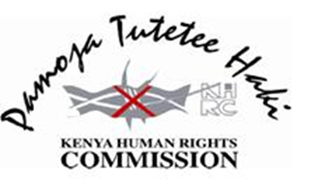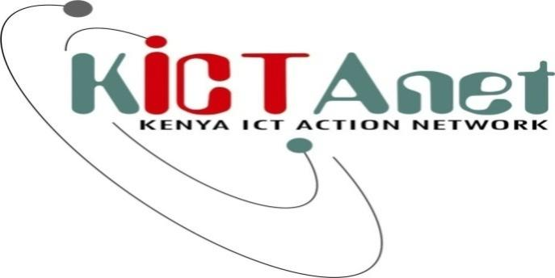

Dear [insert name]
Re: Invitation to the Internet Policy and Human Rights Workshop at the Panafric Hotel on Wednesday 5th February 2014

The Kenya Human Rights Commission (KHRC) and the Kenya ICT Action Network (KICTANet), have the pleasure of inviting you to a one day workshop on Internet and Human Rights.

The internet is a powerful and transformative medium that impacts on a wide range of human rights, such as the right to freedom of expression and opinion, and the right to association. As the use of internet becomes ubiquitous, national and international policies related to its development, use, and governance are becoming increasingly interlinked with our ability to harness its benefits. In order to protect the public interest, it is important that a wide range of stakeholders participates in formulating these policies. Civil society and traditional human rights groups in Kenya have an important role to play in ensuring that all Kenyan citizens benefit from the possibilities posed by the internet.

This meeting will aim to:
- Increase the capacity of local groups to understand the linkages between the internet, human rights, and internet governance;
- Build understanding of the legislative and policy environment in Kenya, including concerns about current debates about cybersecurity and cybercrime and their effect on internet freedom;
- Explore the value of a multistakeholder approach in internet policy making and how it could be institutionalised in Kenya;
- Expand the network of groups informed about and engaging in internet policy and governance in Kenya.

We would appreciate confirmation of your participation at your earliest convenience but hope to hear from you Monday January 3, 2014. Kindly do so by writing to Beryl Aidi on baidi@khrc.or.ke and Grace Githaiga on ggithaiga@kictanet.or.ke. We will circulate the Programme by Tuesday 4th February, 2014

We look forward, hopefully, to seeing you on the 5th February 2014.

