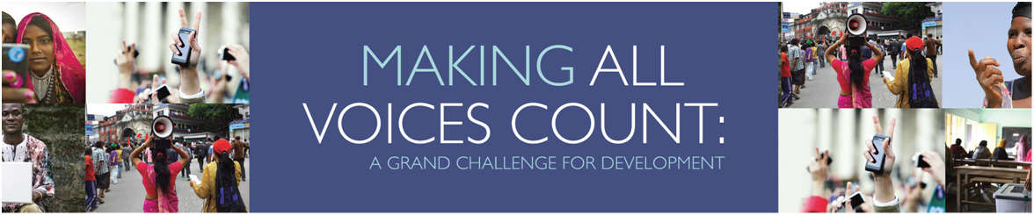

Innovative ICT solutions for social change
Hivos is proud to announce it will lead the consortium, consisting of the Institute of Development Studies (IDS) and Ushahidi, to manage the MAVC fund from the 1st of June 2013. MAVC brings together five donors: U.S. Agency for International Development (USAID), UK Department for International Development (DFID), Omidyar Network (ON), Open Society Foundations (OSF) and Swedish International Development Cooperation Agency (SIDA), who created a $55 million fund to support innovation, scaling-up, and research that will deepen existing innovations and help harness new technologies to enable citizen engagement and government responsiveness.
One of today’s toughest problems is the immense gap between the street and the state. The gap is widened by growing social inequality within societies. A prerequisite for bridging the gap between citizens and government and improving governments’ responsiveness is to engage citizens, and new technology offers a way to achieve this. Today, our information society demands contemporary, innovative solutions to address persistent problems.
MAVC will support such innovative solutions and scale up successful ventures. Evidence-based research will be a key element, given the rapidly evolving nature of interventions in this relatively new field. The ultimate aim of MAVC is to catalyse global action. We wish to engage the general public and raise awareness of the underlying problems surrounding the citizen-government relationship.
This partnership will seek inclusive ways to empower all citizens to voice their concerns and demands, and to improve governments’ responsiveness and accountability to those citizens. In order to build trusting relationships between citizens and government, MAVC will aim to fund collaborative efforts rather than one-sided approaches. .
MAVC focuses on four areas:
• Backing innovative ideas and technology solutions
• Building an evidence base on what works and why
• Scaling up successful initiatives and responses
• Catalyzing global attention and action around these issues
We need help from new and different voices to repair the broken links between governments and citizens.
Take part in our challenge!
Get in touch with us about your ideas to innovate, scale-up, research or catalyze global action
info@mavc.net
http://makingallvoicescount.org

