Let’s free the Internet!

Are you interested to participate in a workshop on themes related to internet freedom: Access to connectivity; privacy and freedom of expression; neutrality and access to content.
Express your interest by filling the questionnaire below before end of the day, 8th May, 2013

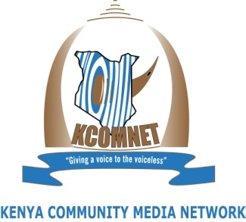

Project background
Freenet is a project which aims to develop a collaborative documentary film project about the future of freedoms in the internet, with the perspective of countries from the Global South. It has the support of four offices from Ford Foundation: FF Brazil, FF Kenya, FF India and FF New York.

As part of the project’s research process four Brazilian organizations which are jointly running the project have partnered with Kenya Community Media Network (KCOMNET) to hold the first Freenet workshop in Kenya from 13th to 17th of May 2013, Shalom House, Ngong Road.

The workshop will engage audio-visual and human rights activists with issues relating to internet freedom; explore the manifestation of such issues locally and enhance audio-visual capabilities for human rights activism. At the end of the workshop participants will produce 3-5 short films to be embedded at the Freenet collaborative film platform and produce video inserts that could be part of the final cut of the full length documentary.

Currently we are in the process of shortlisting participants. Please fill all the spaces in this questionnaire to give us details of your background.
1. Name:
Type your name here

2. Age:

3. Gender:

4. Institutional affiliation (if any):

5. City of current residence:

6. What are the main issues you're involved with in your work?

7. How does audiovisual projects help to frame/advance these issues?

8. How often do you use the Internet?

9. Is it easy for you to be online – in terms of availability, price and quality of connection?

10. If not, why?

11. Are you interested on issues related to Human Rights in the Internet?

12. Do you know about any cases related to violation of rights online or through the Internet or mobile phones (such as violation of privacy, restrictions to freedom of expression, censorship or limitations to access content, for example)?

13. If the previous answer was yes, please share the story in a short paragraph.
14. Do you have any experience in registering and telling stories related to Human Rights and the Internet?

15. Do you have interest in engaging in activities related to the issues above?

16. Do you have any experience in collaborating online with peers? If yes, please tell us something about it.

17. What do you expect from this workshop?

18. What kind of content and/or approach would benefit you more?
19. What are your main interests related to audiovisual?

20. What are your main interests related to the Internet?

21. Are you interested in being part of a network of people working for the defense of Human Rights related to the Internet, working mainly online?

22. Why?

Thank you for taking time to fill this through. We look forward to having you.
Send your questionnaire to the following email: njuki@kcomnet.org

