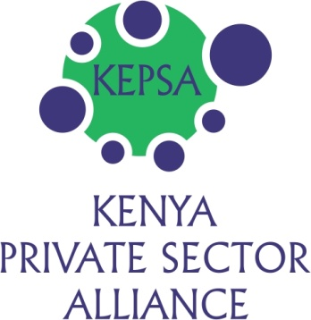

THE ROLE KEPSA HAS BEEN PLAYING IN STRENGTHENING
THE KENYA NATIONAL CHAMBER OF COMMERCE & INDUSTRY (KNCCI),
THE MICRO & SMALL ENTERPRISES FEDERATION (MSEF) & OTHER BMOS
_______________________________________________________________________

INTRODUCTION
One of the key mandates of KEPSA is BMO development in order to strengthen member advocacy and in return strengthen KEPSA’s advocacy. Of more than 70 BMOs in the country almost half do not have the capacity to carry out adequate advocacy for their members for various reasons. Some of the sectors do not have BMOs making it difficult to articulate their advocacy concerns. For this reason, KEPSA takes BMO development very seriously and each year focuses on one or two BMOs that need strengthening or sectors that need to be organized into a BMO. KEPSA works closely with partner and other stakeholders to achieve this.

From 2005 KEPSA has supported the strengthening of the following BMOs:-

- KENYA HEALTHCARE FEDERATION (KHF)

- Registration process – application and follow up to registration in May 2008.
- Meetings – KEPSA was the venue of the meetings.
- Secretarial services – an officer was appointed to assist in convening meetings, taking minutes, etc.
- Link with the Government – seeking Health Ministerial Stakeholders Forums, relaying information from Ministry of Health, etc.

KHF is a success story. It has managed to bring harmony in the sector and is now able to dialogue directly with the public sector on matters of healthcare focusing on policy, service delivery and supply chain issues. Through referral by KEPSA, the federation secured funding from the Business Advocacy Fund (BAF) to conduct a baseline study, the results of which would guide the development of a policy framework for public private partnerships, and ensure a well-coordinated approach to healthcare delivery.

- KENYA ICT FEDERATION (KIF)

KEPSA and the stakeholders in the ICT Sector engaged in a process similar to that outlined above for KHF. Through a harmonized approach the ICT Sector was able to achieve a lot. The most recent was the approval from East African Community partners to remove taxes on set top boxes (the equipment that converts analogue television signals to digital ones). The tax exemption is among other policy measures aimed at making the devices affordable, with the end result of boosting their uptake as the country prepares for switch-over to digital broadcasting.

For MSEF and KNCCI, KEPSA has worked tirelessly with partners and even Government to ensure that these two critical sectors of Business are strong to support their members and to participate in KEPSA among other members.

- MICRO & SMALL ENTERPRISES FEDERATION (MSEF)

The MSE Sector is crosscutting and, if managed properly, has a lot of potential to contribute to fast growth of the economy. This is one single the sector that can lead in addressing the problem of unemployment especially amongst the youth in this country.

It is on this background that in 2005 KEPSA started engaging with the different stakeholders on how the sector can be restructured. Two main areas were identified as requiring immediate attention.

- Federating the Membership – although the sector has the largest number of BMOs, they did not have a platform through which they can pursue issues with the public sector. Federating the sector therefore became a priority. Through extensive consultations, both with the public sector and other stakeholders, the Micro & Small Enterprises Federation (MSE-F) was formally registered in 2007. Thereafter a sensitization exercise aimed at recruiting members was carried out countrywide.

- MSE Bill – the sector was faced with myriad of challenges, the most critical being the fact that it did not have a parent ministry. This made it very difficult to pursue any issues. To address this challenge, KEPSA assisted the sector in pursuing the MSE Bill which provided solutions to most of the challenges in the sector. This was achieved in December 2012 with the assenting by the President to the MSE Act.

KEPSA took the lead in above two processes by sourcing funding and dedicating an officer. In addition, a few KEPSA directors championed the processes.

- From 2010 it became apparent that the MSEF had governance issues and needed to be assisted in reorganizing itself. The first step was to relook at the constitution and streamline it to allow for modern trends and also align it to the country’s constitution. Members engaged on this process and finally approved a new constitution in April 2012.
- The next step was to hold elections under the new constitution. An Independent Electoral Board (IEB) made up of KEPSA, Ministry of Trade, NCCK, Vision 2030, ALGAK, ICPAK was formed and mandated to start preparations for elections immediately. The chair and secretary of the IEB were representatives from ICPAK and NCCK respectively.
- The IEB had a tight schedule within which to conduct the elections by August 2012. This was not possible and an extension was sought to 10th November 2012. Luckily preparations were finalized and elections held during an Annual General Meeting on 10th November 2012 attended by approximately 100 delegates.

KEPSA coordinated this process successfully in spite of funding challenges. The process to amend the constitution was funded by CIPE and on request by KEPSA the balance was to be used on the elections. However, the process took longer than anticipated but because KEPSA was determined to see the process to the end, it chipped in with a little funding to facilitate the Annual General Meeting.

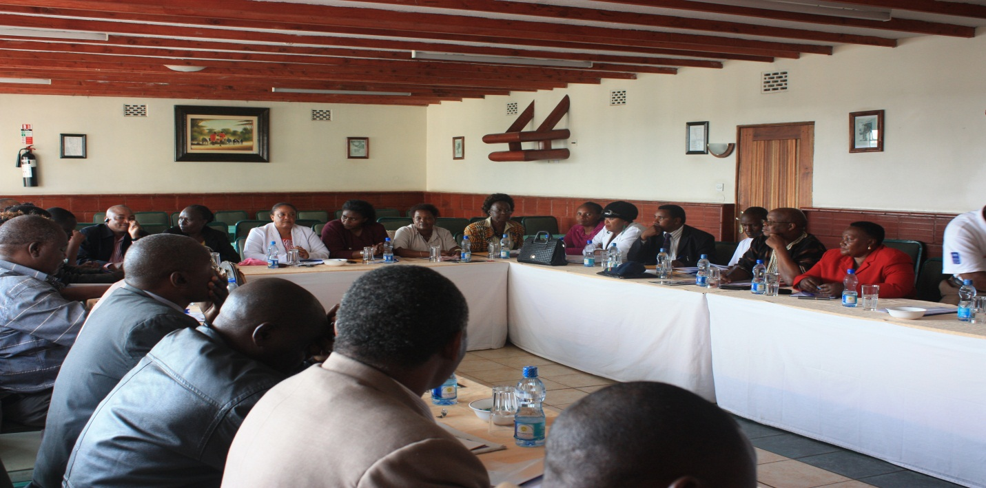
MSEF Special Governing Council meeting at Comfort Hotel that ratified the new constitution

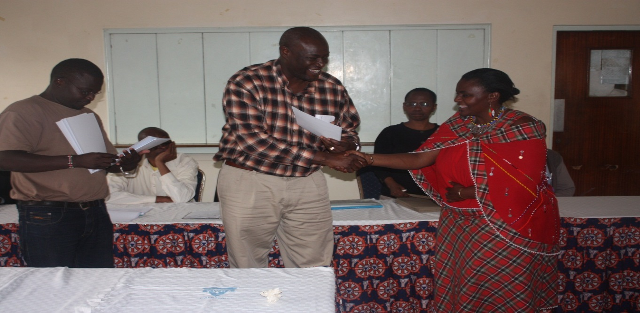
MSEF IEB Representing the Ministry of Trade presenting a certificate to the new Chairperson of MSEF at
The Annual General Meeting held on 10th November 2012 at the YWCA.

- KENYA NATIONAL CHAMBER OF COMMERCE & INDUSTRY (KNCCI)
2010 – 2011
- KEPSA led a Rejuvenation Steering Committee (RSC) that worked on amending KNCCI’s Memorandum & Articles of Association (M&A) to align it to modern governance trends and especially the Kenyan constitution with devolved structures.
- The RSC was made up of KNCCI officials, Ministry of Trade and KEPSA BMO members.
- The process entailed gathering input from KNCCI membership countrywide, analyzing the information and preparation of a draft M&A.
- The draft was subjected to in-depth discussions between the RSC and KNCCI before being circulated to the membership.
- The final draft was finally approved by KNCCI membership at an Annual General Meeting on 28th November 2011 which was attended by more than 200 delegates. The M&A was thereafter registered by the Registrar of Companies.
- The process was supported by Anjarwalla & Khana Advocates and funded by UNDP.

2012
- KNCCI’s elections that were due to be held in April 2010 were postponed, with approval of the Registrar of Companies, so that they can be held under the new M&A. Going by the M&A the elections were due by end of April 2012.
- In February 2012, KNCCI started implementing the new M&A starting with appointing an Independent Electoral Board (IEB) to conduct elections and requested KEPSA Chairman, Eng. Patrick Obath, to chair it. The IEB comprised 9 members picked from the former provinces, i.e. Nairobi, Central, Coast, Eastern, North Eastern, Western, North and South Rift Valley. These were picked by members from those areas.
- The IEB had only 3 months to organize the county and national elections. The team started by developing election guidelines which were used by the 9 IEB members, assisted by Ministry of Trade Officers, to conduct county elections in their respective areas within the month of March. 42 counties successfully held elections. The other 5 did not due to lack of membership quorum which had been set at a minimum of 25 per county.
- Due to various challenges the national elections were not held in April. The Attorney General got involved and he appealed for the process to be postponed for 45 days to allow dialogue with a group that was claiming to have been locked out of the election process at the county. The IEB complied with all the requirements of the dialogue but the other group reneged on all the commitments. The IEB therefore proceeded with the election plans. At an Annual General Meeting held on 18th June 2012 attended by approximately 400 delegates KNCCI membership elected the National Chair and the Vice. The County Governors and their deputies met immediately thereafter and elected the board of directors for the national office. Returns were presented to the Registrar of Companies but were not filed because there was a court order against the filing by the group that had requested for the AG’s intervention.

This process was partly funded by BAF and members through the nomination fees.
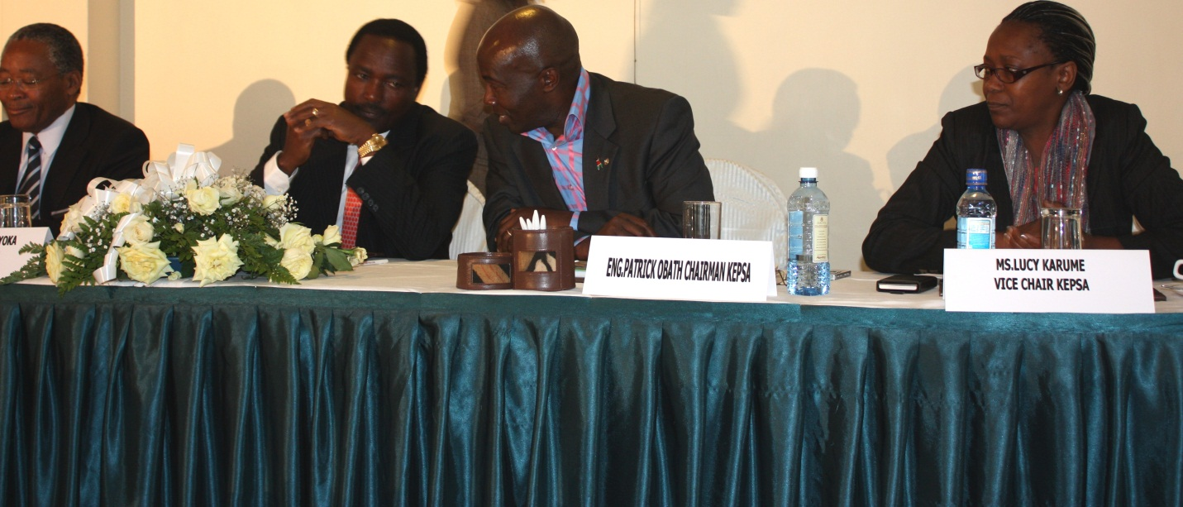
From Left: Hon. Chirau Ali Mwakwere (former Minister for Trade), Vice President, Hon. Kalonzo Musyoka, Eng. Patrick Obath (KEPSA Chairman) and Ms. Lucy Karume (KEPSA Director) during KNCCI AGM on 28th November 2011 at Panafric Hotel when the new constitution was validated.

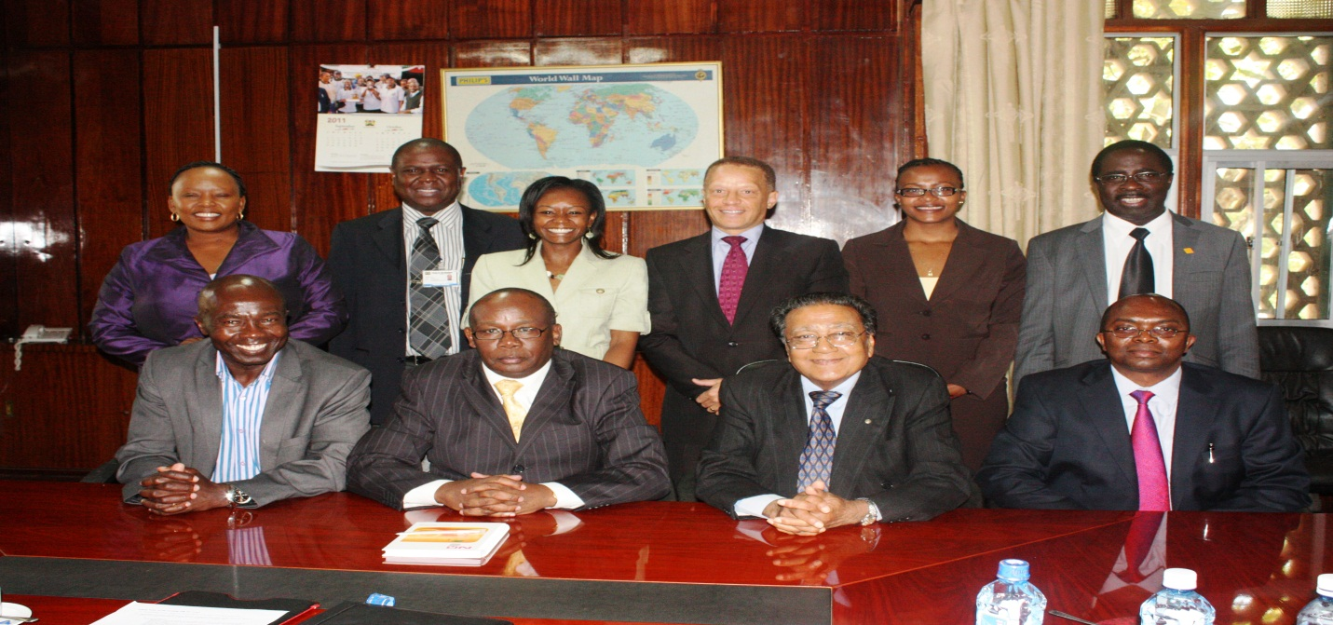
KEPSA Delegation with the Attorney General in early 2012. KNCCI was among the issues of discussion in the meeting.
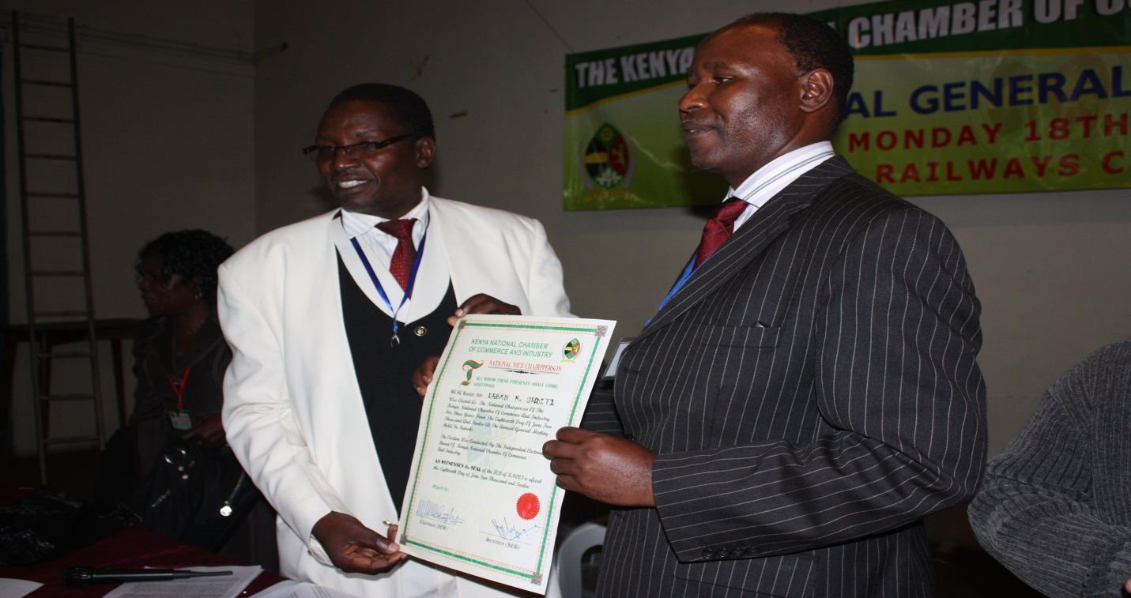
From Left: KNCCI IEB Vice Chairman presenting a certificate to the elected National Vice Chairman.

CONCLUSION

From the work carried out on the 4 BMOs listed above, it is clear the role of support to the BMOs is still very relevant. KEPSA will therefore continue incubating deserving BMOs by offering meeting rooms for an initial period of 3 months. This will allow stakeholders to deliberate on the steps to take to build their BMOs. KEPSA will assist BMOs according to the needs for each in its uniqueness. Organisations like BAF, UNDP and CIPE and other KEPSA members have been great and valuable partners in this process of BMO development. The Government too when called upon e.g. Ministry of Trade, the AG office, the CJ office and others have also assisted when there has been a need.

The ultimate goal is to achieve self-sustainability in terms of having a secretariat and ability to coordinate specific sector advocacy while KEPSA concentrates on coordinating all the BMOs on crosscutting advocacy.

__________________________________________________________________________

