GOVERNMENT OF KENYA
OFFICE OF THE PRIME MINISTER

Competitive Partnerships Initiative for Kenya
Concept Paper
December 2010

1.0 Objective

The purpose of this note is to propose a public-private partnership approach for improvement of productivity and competitiveness of key economic sectors in Kenya.

The note has been prepared by the Office of the Prime Minister (OPM) in consultation with the National Economic Social Council (NESC).

OPM and NESC are of the opinion that the implementation of a sector competitiveness approach could :

- help in achieving and sustaining a set target GDP growth rate of 10% per annum from the year 2012 going forward

- facilitate new business formation which would also contribute to the realization of the targeted results in the economic pillar of the Kenya Vision 2030.

- stimulate and enable innovation by promoting interaction of multiple suppliers, competitors in the private sector, as well as related government services to foster knowledge creation and knowledge transfer.

2.0 Background

The Kenya Vision 2030 aims at transforming Kenya into a rapidly industrializing and middle income country by 2030 through achieving and sustaining a GDP growth rate of 10% per annum starting 2012. This ambitious growth rate relies heavily on the private sector being a successful engine for economic growth and development. The Government of Kenya is committed to providing an enabling business environment which will enhance private sector growth and competitiveness that will contribute to the country’s medium and longer term objectives in line with the Kenya Vision 2030. To facilitate this there is a need to create formal engagement structures and partnerships to facilitate the sharing of ideas between the Government and its various stakeholders.

The Competitive Partnerships Initiative is intended to build upon two sets of initiatives that have been going on over the last two years. These are the sector development initiatives and the public private dialogue. It also aims to sharpen the focus on addressing specific binding constraints and increasing investment generation efforts that are expected to achieve most impact in the short-mid-term. It also aims to sharpen the focus on addressing specific binding constraints and increasing investment generation efforts that are expected to achieve most impact in the short-mid-term.

a. Cluster development initiatives

The concept of ‘cluster’ generally refers to a geographical agglomeration or concentration of companies, suppliers, service providers and associated institutions engaged in a particular economic activity linked by externalities and complementarities (GCR 2008-09). Over the last two years there have been a number of cluster development approaches that have been initiated. These include:

- NESC during its 17th Council held on May 29-30th 2009, recommended the adoption of a cluster development strategy as part of regional and national competitiveness strategies. Accordingly, priority sectors have been identified for the initial implementation of the cluster strategy. These are: transport and logistics at the Port of Mombasa, horticulture, sugar, tea, tourism, marine and inland fisheries, livestock, energy, ICT, maize, cotton and dairy.

- NESC also recommended the establishment of a Productivity and Competitiveness Commission to oversee matters of productivity and the country’s investment climate reform agenda and ensure the country is a competitive investment destination.

- The Vision 2030 also advocates for regional manufacturing and industrial clusters as engines for realizing industrialization.

- The fourth component of Kenya Private Sector Development Strategy (PSDS) also aims at improving the productivity and competitiveness of enterprises through the use of the cluster framework

- The Ministry of Industrialization, in collaboration with the Kenya Institute of Public Policy Research and Analysis with the support of ECORYS Netherlands, has recently done a Cluster Analysis for Enhancing Productivity and Competitiveness of the Kenyan Economy, which includes a prioritization of the clusters for implementation.

- The Ministry of Industrialization is currently spearheading a new industrialization policy and development of Action Plans for the implementation of initiatives in select sectors.

b. Public Private Dialogue

In Kenya some form of public-private dialogue (PPD) has been practiced over the last decade and in the development of the Economic Recovery Strategy 2003-2007, special recognition of the role of private sector in development was made.

Soon after the establishment of the Office of the Prime Minister (OPM) in 2008, the Government stepped up PPD with the launch of the Prime Minister’s Round Table (PMRT) with the private sector which takes place on a quarterly basis. The PMRT introduced a more focused approach to PPD where discussions are now better structured, include relevant decision makers and are aimed at producing targeted results. The PMRT meetings and follow up actions have yielded notable results, including inspections and enforcement reforms, 24 hour service at Mombasa Port and the nomination of private sector players to key Boards of Government institutions that support private sector development. However, they have also drawn out the need to sharpen focus and alignment to national development goals and priorities in line with Vision 2030.

To enable a structured engagement with Government where the private sector can speak with one voice, the private sector formed the Kenya Private Sector Alliance (KEPSA) which is the umbrella body for many Business Membership Organizations and Associations. The overall agenda of KEPSA is to provide “one voice” for the private sector to engage in public policy dialogue and hence influence public policy formulation. KEPSA is the interface for private sector in its dialogue with the Government and the private sector voice in the PMRT.

3.0 A Competitive Partnerships Initiative

During 2010, OPM in collaboration with NESC and the WBG have been working to identify an approach that brings together, in a formal way, the cluster development initiatives and the public private dialogue under the umbrella of the PMRT and with the guidance of NESC.

a. Overview of approach

The Competitive Partnerships Initiative is informed by global good practice. It draws upon the experiences of a number of countries that have succeeded in developing new industries that compete effectively in global markets. Be it in electronics in Malaysia and Singapore, car parts and assembly in Morocco or central and eastern Europe, wine from South Africa, salmon from Chile or fresh asparagus from Peru, in all these cases governments played an active role in creating the foundation for sustained and strong private sector expansion and job creation. A sector-based clustering approach has also yielded results in industrial growth and jobs. For instance, the Malaysian Vision 2020 and Industry Master Plans framework led to the creation of industry clusters identified as growth-enhancing sectors ranging from electronics and engineering, ICT Multimedia Super Corridor, petrochemical, palm oil, textiles and apparel, agro-based products, automotive, and machinery among others.

The Competitive Partnerships Initiative encompasses the aspects of the cluster based approach but removes the emphasis on a geographic concentration of industries and provides a holistic approach at sector competitiveness and growth. Clusters might be part of the sector development process for a specific industry, when such industry is geographically concentrated. But clusters are only one tool in the sector development toolbox. What matters is the increased interaction with between stakeholders, and this can take place at many levels, whether in a cluster manner or otherwise. Hence, the emphasis of this approach on sectors development and competitiveness.

The Competitive Partnerships Initiative recognizes the importance and role of three types of enterprises in strengthening the competitiveness of a sector. These are:

- Market Creators: Lead firms that need to be ready and willing to engage with investors to produce clearly defined products or services demanded in the global markets

- Intermediators: typically domestic SMEs or MSMEs which supply inputs such as raw materials, components and services, need to be able to meet the needs of the Market Creators

- Foundation Providers: providers such as financial institutions, training centers and the government itself need to be able to provide the basis for this ecology of firms to function effectively.

Figure 1: The Competitive Partnerships Initiative
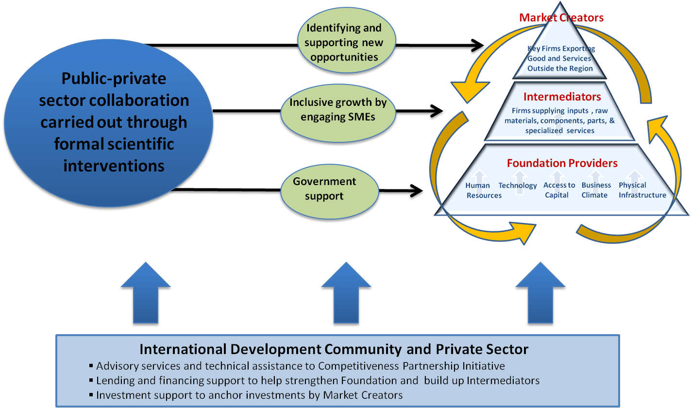

The Competitive Partnerships Initiative typically has four phases:

Phase 1- Identification: A rapid analysis of the competitiveness of specific industries (with a particular look at the demand side), in order to help market players and government identify those sub-industries and products where the country has the best opportunity to be competitive, particularly in terms of boosting exports and attracting FDI.

Phase 2- Sub-Industry Analysis: A deeper analysis of targeted sub-industries to identify specific factors that constrain sector competitiveness

Phase 3- Development of Action Plan: Use this analysis to develop a targeted action plan to systematically remove constraints, prioritizing those constraints that are expected to have the biggest impact on increased investment in the short term. This takes place through structured public private sector level workshops.

Phase 4- Implementation: Undertake the necessary reforms for a given sub-industry. The types of actions for a given sub-sector may include (i) Industry-specific policy and regulatory reforms (ii) improvement of infrastructure (iii) Trade promotion and FDI attraction (iv) Research partnerships and skills partnerships (v) Development and certification of technical standards (v) supply-chain development (bundled production, joint logistics, joint purchasing, etc).

b. Proposed Approach for Kenya

In order to ensure that the Competitiveness Partnerships Initiative can be implemented effectively and efficiently it is important that both the roles and responsibilities of the various parties and the various phases are clearly defined.

The approach will be driven by NESC, OPM, and Sector Working Groups (SWGs). Their proposed roles and responsibilities are as follows:

- NESC : will provide high level guidance and general advice to the Government on the initiative

- PMRT: The PMRT will be responsible for monitoring and tracking the progress of the initiative including uncovering bottlenecks and building consensus on contentious issues.

- OPM: The OPM will have three key roles in the initiative. Firstly it will provide leadership on this initiative at a macro and strategy level to ensure proper coordination across Government. Secondly the Vision 2030 secretariat will provide technical inputs to the initiative. And finally OPM will provide a secretariat for the initiative. This secretariat will coordinate the process and will be the main point of the contact for the Sector Working Groups, the World Bank Group, other development partners and possible technical assistance providers.

- SWGs: A Sector Working Group will be established for each sector (initially Tourism and ICT). The group will comprise of representatives of the specific industry sector including market creators, intermediators, KEPSA, relevant line ministries, etc.

The CWGs will report and account through the PMRT. This will ensure proper consensus building on proposals, structured implementation within the desired timeframe and accountability. The PMRT will track progress and report back to NESC.

The Competitive Partnerships Initiative in Kenya will have the following four phases and proposed timetable:

- Phase 1-Identification of sub sectors (Jan-Feb 2011): Given that Vision 2030 has defined the key economic sectors it is unnecessary to do a rapid analysis of all sectors. Furthermore given that the PMRT has already been engaging actively with the Tourism and ICT sectors it is proposed that these two sectors be the first pilot sectors to launch the process. Other sectors could follow in due course based on experience and lessons learned with the first two pilots. This phase therefore will focus on identifying the specific sub sectors within Tourism and ICT that would benefit most from the sector competitiveness approach.

- Phase 2: Sub Sector Analysis (February –March 2011): The SWGs for
Tourism and ICT working together with OPM secretariat will review existing information and studies on the chosen sub-sector, further analyze any remaining gaps and prepare a report.

- Phase 3: Preparation of Action Plan (April – May 2011): Each SWG will present their analysis at a workshop in May. Following this the SWG will prepare an action plan that will be presented to the PMRT and NESC at the end of May for endorsement.

- Phase 4: Implementation (June 2011- May 2012): The relevant parties – both public sector and private sector will begin implementing the agreed actions. Updates will be provided to PMRT and NESC on a quarterly basis.

This is the proposed process for launching the overall initiative and beginning work on two sectors. It is expected that the same process could be followed for another two sectors in late 2011. The process will be modified as appropriate based on lessons learned from the pilot with Tourism and ICT.

4.0 Next Steps

In order to launch the Competitiveness Partnerships Initiative the following key steps are envisaged:

- Approval of concept paper

- Workshop for stakeholder consultation and discussion of the approach. It is proposed that this workshop be held over two days in the last week of January 2010.

- Preparation and submission of a cabinet memo, based on workshop discussions and outcome, seeking cabinet endorsement for the initiative.

